BEE UNIT 3A

Transformer
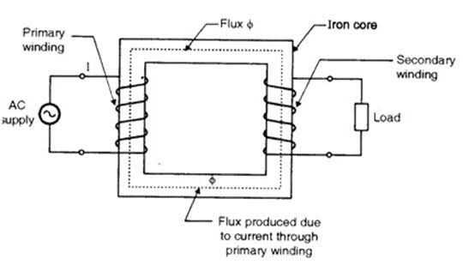

A transformer is a passive electrical device that transfers electrical energy from one electrical circuit to another, or multiple circuits. A varying current in any one coil of the transformer produces a varying magnetic flux in the transformer's core, which induces a varying electromotive force across any other coils wound around the same core. Electrical energy can be transferred between separate coils without a metallic (conductive) connection between the two circuits.

Transformers are most commonly used for increasing low AC voltages at high current (a step-up transformer) or decreasing high AC voltages at low current (a step-down transformer) in electric power applications, and for coupling the stages of signal processing circuits. Transformers can also be used for isolation, where the voltage in equals the voltage out, with separate coils not electrically bonded to one another.

Construction

Closed-core transformers are constructed in 'core form' or 'shell form'. When windings surround the core, the transformer is core form; when windings are surrounded by the core, the transformer is shell form. Shell form design may be more prevalent than core form design for distribution transformer applications due to the relative ease in stacking the core around winding coils.

Turns ratio= N¹/N²=V¹/V²=I²/I¹

Losses

Core losses, collectively called magnetizing current losses, consisting of[9]

Hysteresis losses due to nonlinear magnetic effects in the transformer core, and

Eddy current losses due to joule heating in the core that are proportional to the square of the transformer's applied voltage.

Joule losses due to resistance in the primary and secondary windings.

Leakage flux that escapes from the core and passes through one winding only resulting in primary and secondary reactive impedance.
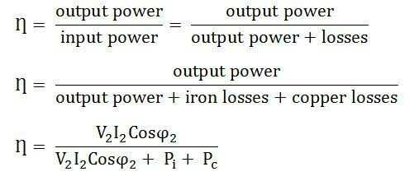
Where, V²= second voltage
I²=second current
Pi= iron loss/core loss
Pc= copper loss/winding loss
Q=power factor
Π=efficiency

